Search

Number of selections

Artifacts created

Handle

Click to open

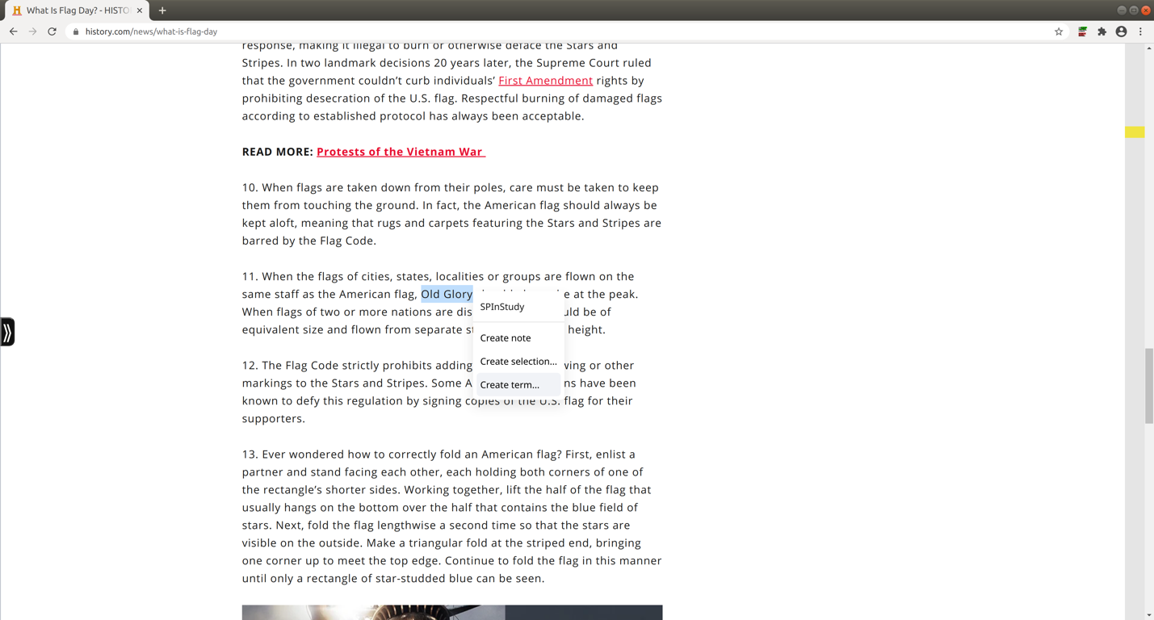

Search

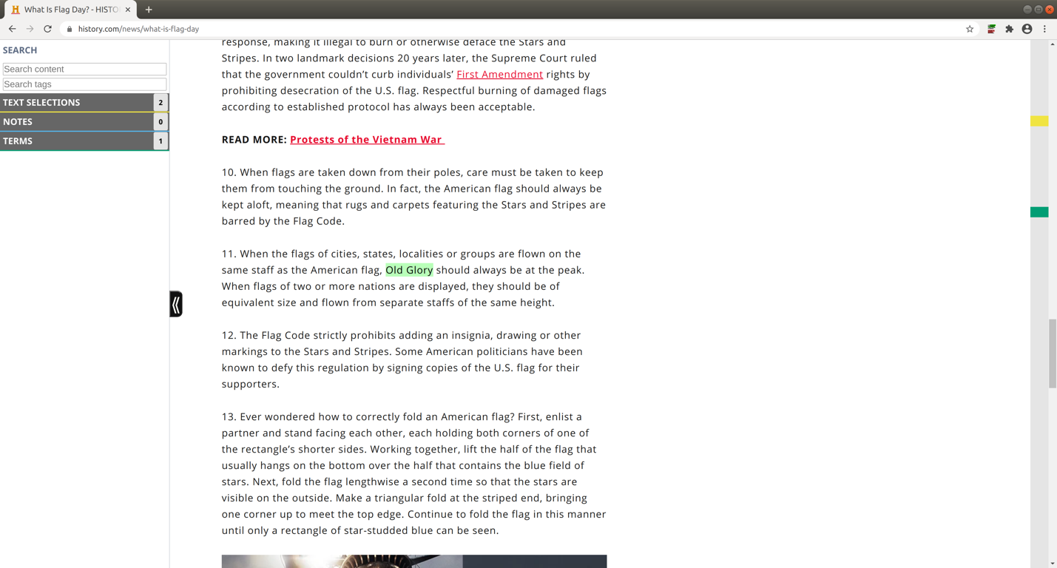

Artifacts created

Handle

Number of artifacts



Click to close

Click to open

Click to open

Click to open

Click to open

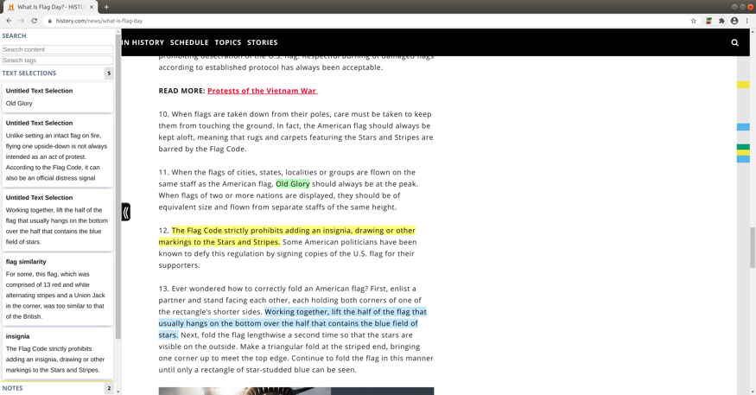

Term created

**Sidebar**

**Gutter**

Note created

Sidebar search

Selection created

Nubs

Click to open

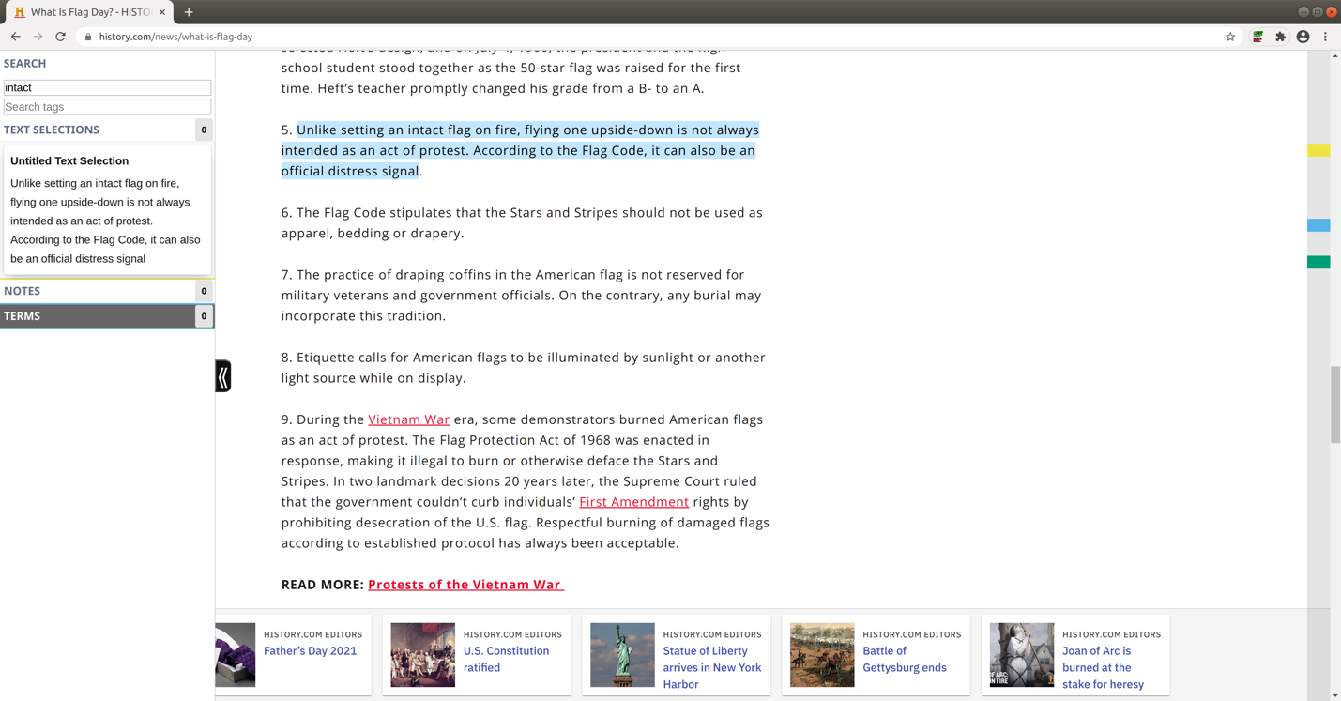

1

Enter search word



1